# Linux查看系统版本

shell> uname -a

shell> lsb_release -a

shell> cat /proc/version

shell> cat /etc/redhat-release

shell> cat /etc/issue

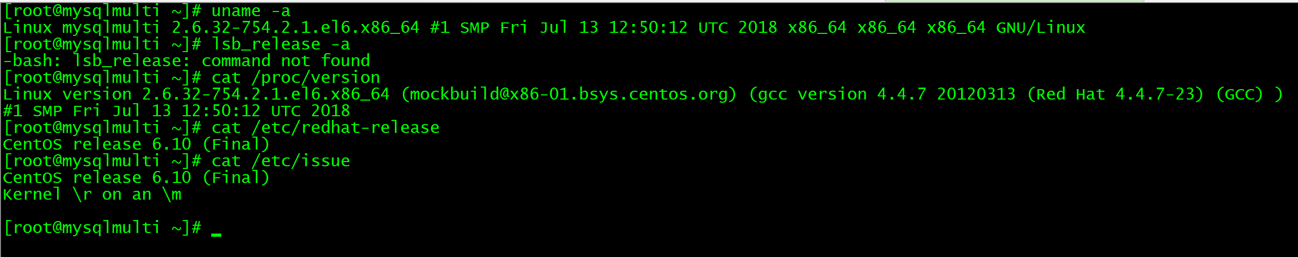

# 安装相关包

shell> yum -y install gcc glibc libaio libstdc++ libstdc ncurses-libs

# 如有则卸载自带mysql （手动删除 /etc/my.cnf或者/etc/mysql）

rpm -qa | grep mysql

rpm -e mysql #普通删除模式

rpm -e --nodeps mysql #强力删除模式

=============第二步============

# 基本配置

shell> groupadd mysql

shell> useradd -r -g mysql -s /bin/false mysql

shell> ll /root/mysql-5.7.15-linux-glibc2.5-x86_64.tar.gz

shell> cd /root

shell> tar -zxvf mysql-5.7.15-linux-glibc2.5-x86_64.tar.gz

shell> mv /root/mysql-5.7.15-linux-glibc2.5-x86_64 /usr/local/mysql

shell> cd /usr/local/mysql

shell> mkdir -p /var/run/mysqld

shell> mkdir -p /usr/local/mysql/data3306 /usr/local/mysql/binlog3306

shell> mkdir -p /usr/local/mysql/data3307 /usr/local/mysql/binlog3307

shell> mkdir -p /usr/local/mysql/data3308 /usr/local/mysql/binlog3308

shell> mkdir -p /usr/local/mysql/data3309 /usr/local/mysql/binlog3309

shell> chmod 750 /var/run/mysqld /usr/local/mysql/data* /usr/local/mysql/binlog*

shell> chown -R mysql:mysql /usr/local/mysql/ /var/run/mysqld

==============第三步===============

# 配置参数文件

shell> vi /etc/my.cnf

[mysqld_multi]

mysqld = /usr/local/mysql/bin/mysqld_safe

mysqladmin = /usr/local/mysql/bin/mysqladmin

#user = root

#password = rootpwd

[mysqld3306]

port = 3306

server_id = 3306

basedir =/usr/local/mysql

datadir =/usr/local/mysql/data3306

log-bin=/usr/local/mysql/binlog3306/mysql-bin

socket =/tmp/mysql3306.sock

log-error =/var/log/mysqld3306.log

pid-file =/var/run/mysqld/mysqld3306.pid

[mysqld3307]

port = 3307

server_id = 3307

basedir =/usr/local/mysql

datadir =/usr/local/mysql/data3307

log-bin=/usr/local/mysql/binlog3307/mysql-bin

socket =/tmp/mysql3307.sock

log-error =/var/log/mysqld3307.log

pid-file =/var/run/mysqld/mysqld3307.pid

[mysqld3308]

port = 3308

server_id = 3308

basedir =/usr/local/mysql

datadir =/usr/local/mysql/data3308

log-bin=/usr/local/mysql/binlog3308/mysql-bin

socket =/tmp/mysql3308.sock

log-error =/var/log/mysqld3308.log

pid-file =/var/run/mysqld/mysqld3308.pid

[mysqld3309]

port = 3309

server_id = 3309

basedir =/usr/local/mysql

datadir =/usr/local/mysql/data3309

log-bin=/usr/local/mysql/binlog3309/mysql-bin

socket =/tmp/mysql3309.sock

log-error =/var/log/mysqld3309.log

pid-file =/var/run/mysqld/mysqld3309.pid

文件：



================第四步==============

# 添加环境变量

shell> echo "PATH=$PATH:/usr/local/mysql/bin " >> /etc/profile

shell> source /etc/profile

================第五步===============

# 安装,完成后记住root密码

shell> bin/mysqld --initialize --user=mysql --datadir=/usr/local/mysql/data3306 --explicit_defaults_for_timestamp

shell> bin/mysqld --initialize --user=mysql --datadir=/usr/local/mysql/data3307 --explicit_defaults_for_timestamp

shell> bin/mysqld --initialize --user=mysql --datadir=/usr/local/mysql/data3308 --explicit_defaults_for_timestamp

shell> bin/mysqld --initialize --user=mysql --datadir=/usr/local/mysql/data3309 --explicit_defaults_for_timestamp

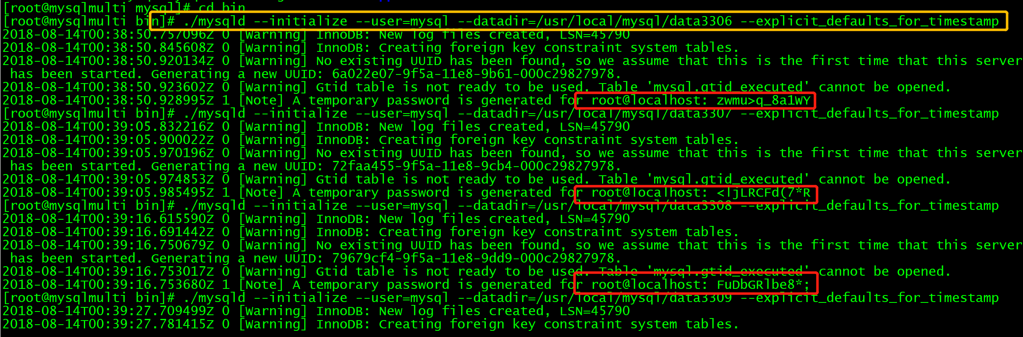

=================第六步================

# 启动实例服务

shell> mysqld_multi report

shell> mysqld_multi start 3306,3307,3308,3309

shell> netstat -ntlp | grep mysql

shell> ll /tmp/mysql*.sock

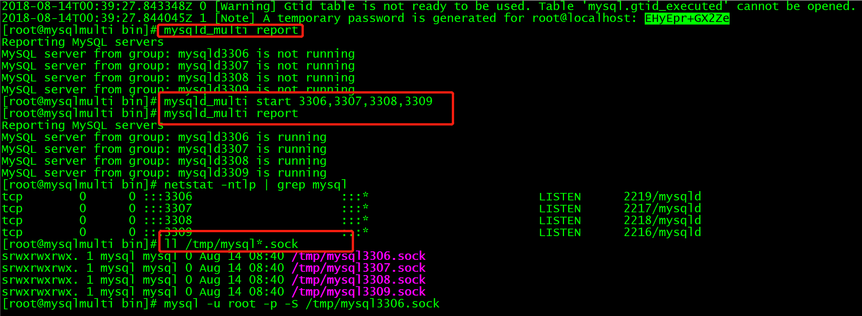

==================第七步=================

# 访问管理

# 访问数据库(进入后要求更改root密码)

shell> mysql -u root -p -S /tmp/mysql3306.sock

Enter password:

shell> mysql -u root -p -S /tmp/mysql3307.sock

Enter password:

mysql> ALTER USER 'root'@'localhost' IDENTIFIED BY 'rootpwd';

mysql> select Host,User from mysql.user;

# 超级管理员

mysql> create user root@'192.168.1.%' IDENTIFIED by 'rootpwd';

mysql> grant all privileges on *.* to root@'192.168.1.%';

mysql> flush privileges;

# 可用端口登录了(此时登录账户为: root@'192.168.1.%')

shell> mysql -h 192.168.1.110 -u root -p -P3306

shell> mysql -h 192.168.1.110 -u root -p -P3306

# 关闭某个实例

shell> mysqladmin -uroot -prootpwd -S /tmp/mysql3306.sock shutdown

#添加自启动

shell> cat /etc/rc.local

shell> echo "/usr/local/mysql/bin/mysqld_multi --defaults-extra-file=/etc/my.cnf start 3306,3307,3308,3309" >> /etc/rc.local

# 添加防火墙规则 (贴在 icmp-host-prohibited 的上面)

释放3306/7/8/9端口